**ROCKSAT-XN**

**SPARK**

**Assembly Instructions for Laboratory Model**

M. J. Bailey, S. S. Lawson, M. J. Schwab, J. N. Stefancik, C. A. Romero-Talamás

Dusty Plasma Laboratory

University of Maryland, Baltimore County

1000 Hilltop Circle, Catonsville MD 21250

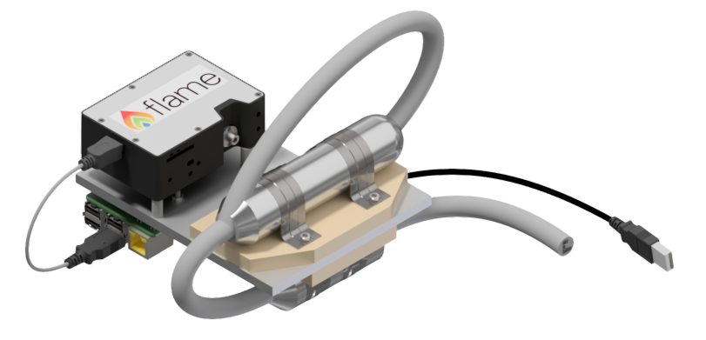

**Figure 1:** The Completed Spark Gap Device Assembly. The device shown is the laboratory model, for use in ground-based testing.

# TABLE OF CONTENTS

**Part I –** Acronyms **4**

**Part II –** Parts List **5**

**Part III –** Vendors/Suppliers **7**

**Part IV –** Transformer Assembly **8**

**Part V –** Spark Gap Assembly **12**

**Part VI –** Final Assembly **20**

**Part VII –** Working Drawings **22**

**Part VIII –** Setting Up the Raspberry Pi **23**

**Part IX –** Manufacturing Details **26**

**Part X -** Testing **27**

# Part I

# Acronyms

DPL Dusty Plasma Lab

KPIF Keith Porter Imaging Facility

MMC McMaster-Carr Supply Company

UMBC University of Maryland Baltimore County

LTM Laboratory Test Model

SGA Spark Gap Assembly

# Part II

# Parts List

|  |  |  |  |  |  |
| --- | --- | --- | --- | --- | --- |
| **Part** | **Supplier** | **Supplier**  **ID #** | **DPLX**  **Part #** | **Quantity** | **Assembly Parent** |
| M3X.5mm  SS Hex Nut | MMC | 91828A211 | NA | 8 | 4-Spark Gap  4-Transformer |
| M3X.5mm  SS Phillips Flat Head  12mm | MMC | 92010A122 | NA | 8 | 4-Spark Gap  4-Transformer |
| M3X.5mm  SS Phillips Flat Head  14mm | MMC | 92010A787 | NA | 14 | 8-Spark Gap  6-Transformer |
| Steel Clamp | MMC | 9429T360 | NA | 4 | 2-Spark Gap  2-Transformer |
| Aluminum  Foil Wrap | Giant | NA | P015 | 1 | Spark Gap |
| Baffle  Inner | Keith Porter Imaging Facility | NA | P003 | 2 | Spark Gap |
| Baffle  Outer | Keith Porter Imaging Facility | NA | P004 | 2 | Spark Gap |
| Electrode | UMBC Mechanical Engineering Dept. |  | P001 | 2 | Spark Gap |
| Electrode  Set Screw | UMBC Mechanical Engineering Dept. |  | P006 | 2 | Spark Gap |
| Ferrite Choke |  |  | NA | 2 | Transformer |
| Quartz Tube | GREATGLAS, Inc. |  | P025 | 1 | Spark Gap |
| Spark Gap Shielding Top |  |  | P029 | 1 | Spark Gap |
| Spark Gap Shielding Middle |  |  | P028 | 1 | Spark Gap |
| Spark Gap Shielding Bottom |  |  | P027 | 1 | Spark Gap |
| Transformer |  |  | P026 | 1 | Transformer |
| VIPE Shielding Top |  |  | P031 | 1 | Transformer |
| VIPE Shielding Middle |  |  | P032 | 1 | Transformer |
| VIPE Shielding Bottom |  |  | P030 | 1 | Transformer |
| Viton Insulation |  |  | P033 | 1 | Spark Gap |
| Viton Insulation |  |  | P034 | 1 | Transformer |
| Wire Shielding | Electriduct |  | NA | 1 | Spark Gap  Transformer |
| Lab Base Plate Small PV | UMBC Mechanical Engineering Dept. | NA | P014 | 1 | Base Plate |
| Raspberry Pi Standoffs  Delrin | MMC |  | P021 | 4 | Final Assembly |
| Ocean Optics Standoffs  Delrin | MMC |  | P017 | 3 | Final Assembly |
| High Voltage Flex Wire | MMC | 9620T14 | NA | As Needed | Spark Gap  Transformer |

# Part III

# Vendors/Suppliers

* MSC Direct Industrial Company

<https://www.mscdirect.com/>

* McMaster-Carr Supply Company

<https://www.mcmaster.com/>

* Formlabs Inc.

<https://formlabs.com/>

* Keith Porter Imaging Facility

<https://kpif.umbc.edu/>

* UMBC Mechanical Engineering Dept.

<https://me.umbc.edu/>

* GREATGLAS, Inc.

<http://www.greatglas.com/>

* Electriduct, Inc

<https://www.electriduct.com/>

# Part IV

# Transformer Assembly

**Step 1**

* Assemble the G10 shielding for the VIPE transformer
* Insert -92010A122 M3 12mm Screws into the VIPE Insulation Middle Part (Fig1)
* Insert -92010A787 M3 14mm Screws into the VIPE Insulation Middle Part (Fig1)
* 12mm screws face up and will be used to fasten 2 clamps. The 14mm screws will be used to connect this piece to the baseplate.
* 12mm Screws are shown in the top and bottom of the picture 14mm are in the center

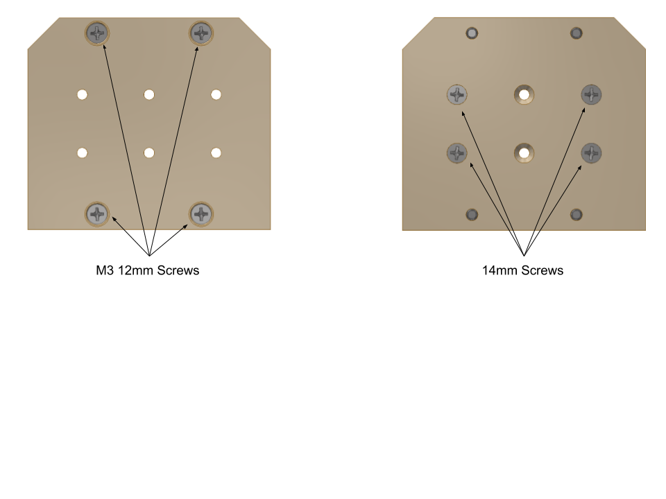

Fig2

* These screws must be flush with the surface of the insulating plate, otherwise the assembly could become misshapen.
* Only 4 screws are necessary to fasten the G10 to the baseplate for the LTM

**Step 2**

* Install the VIPE Insulation Bottom
* Insert the VIPE Insulation Bottom over the 4 screws that are on the bottom of the VIPE Insulation Middle.

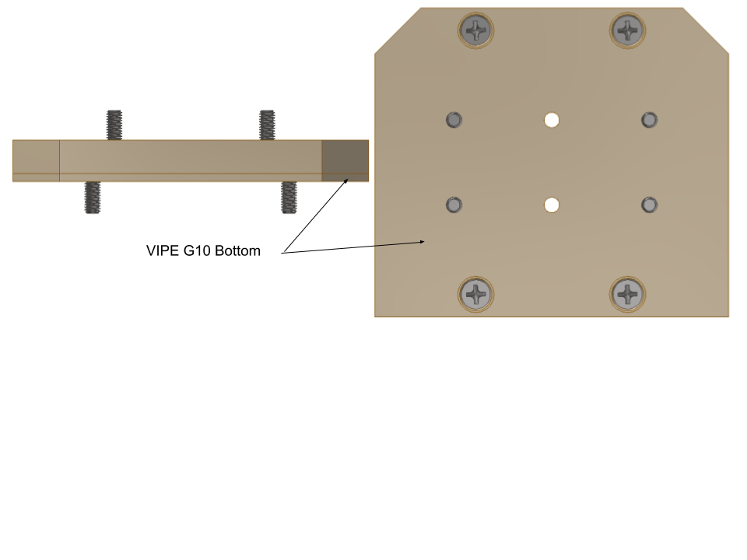

Fig 3

**Step 3**

* Install the Shielding plates to your mounting surface.
* The baseplate we used for flight had tapped holes and our lab test model had recesses for nuts. Either method will work for assembly.
* If you are using recesses to allow for your bolts as shown in the next image it is important to know the transformer and the spark gap are on opposite sides of the plate and you need to install the transformer first.
* Attach the 4 screws that pass through the shielding material to your baseplate using one of the two methods explained above. If using nuts as shown in Fig4 use 91828A211 M3 SS Hex Nuts. There should be no part of the screw that extends out from the baseplate on the opposite side.

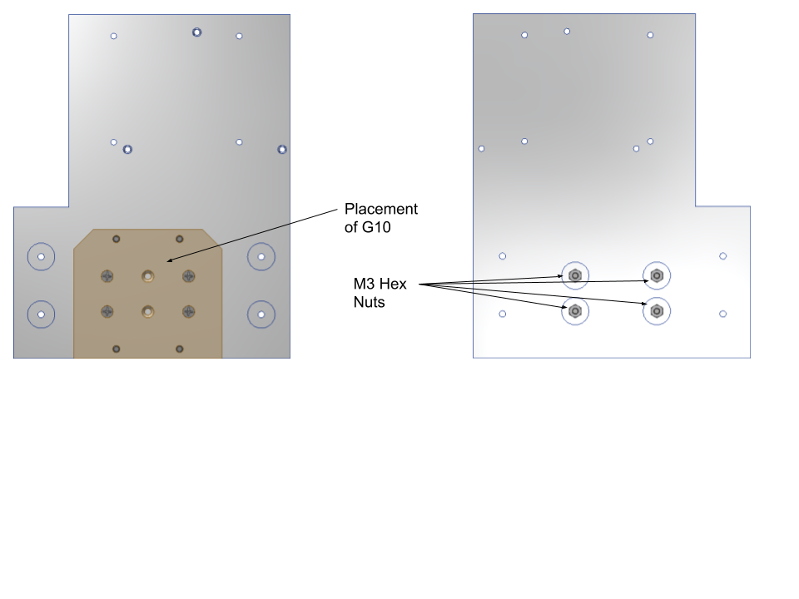

Fig 4

**Step 4**

* Install the VIPE Shielding Top.
* Place the VIPE Shielding Top over the four screws and set this assembly aside in a safe area.
* The 12mm screws should be sticking out of the top

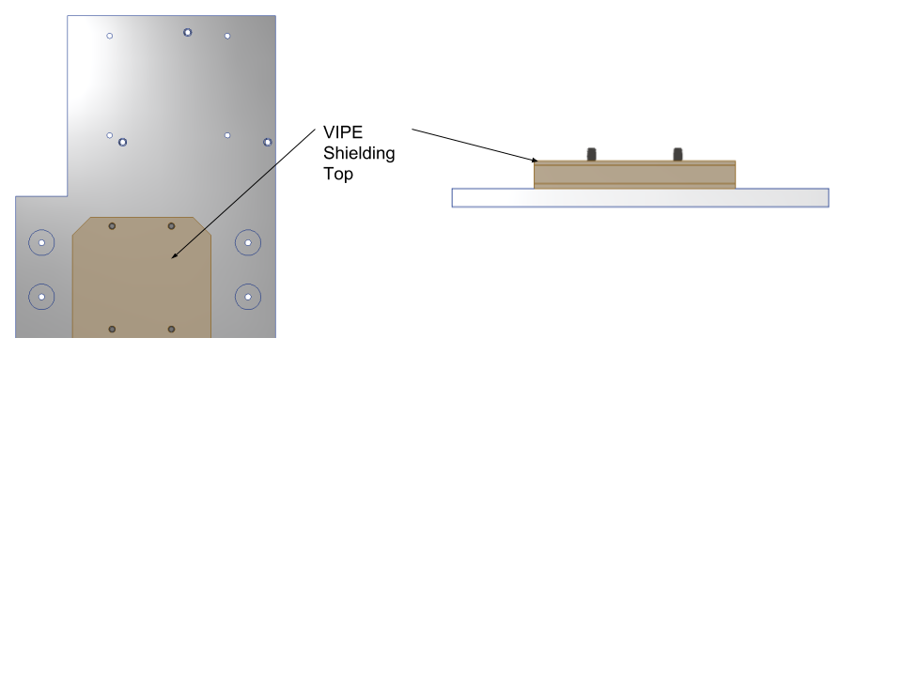

Fig5

**Step 5**

* Now start preparing the transformer for attachment to the G10 insulation
* Connect two wires to both ends of the transformer making sure the step up in voltage is going in the correct direction for the transformer you are using.
* These wires should be around 3” long or long enough for you to comfortably solder them to another wire
* You will have a total of four wires soldered to the transformer now
* Wrap solder joint with shrink connectors or electrical tape. Keep in mind electrical tap will outgas significantly in vacuum

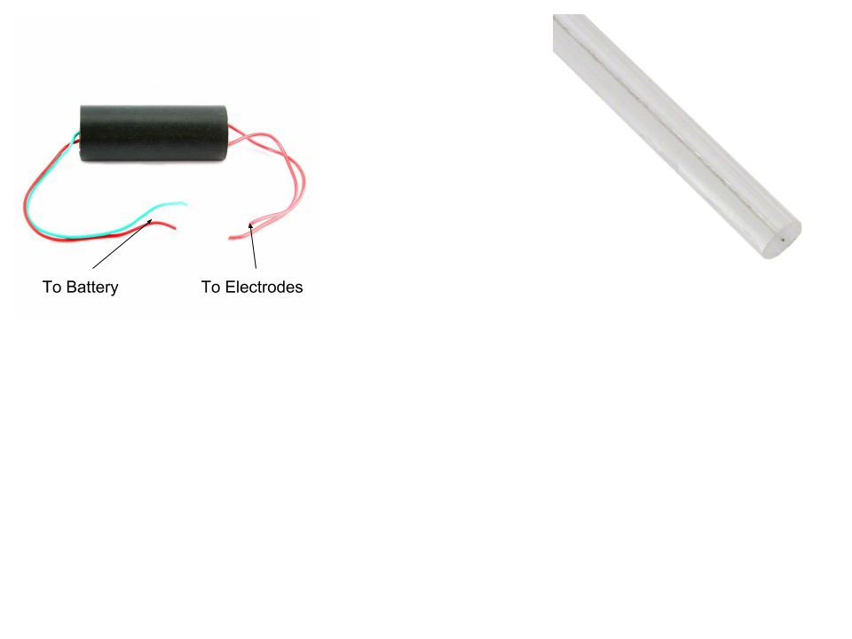

Fig6

**Step 6**

* Wrap the transformer in .125” Viton
* Wrap the transformer in wire mesh shielding
* Cut a 6”-7” length of the wire mesh shielding.
* Insert the Transformer into the mesh shielding making sure about 1.5” hangs over each end of the Transformer.

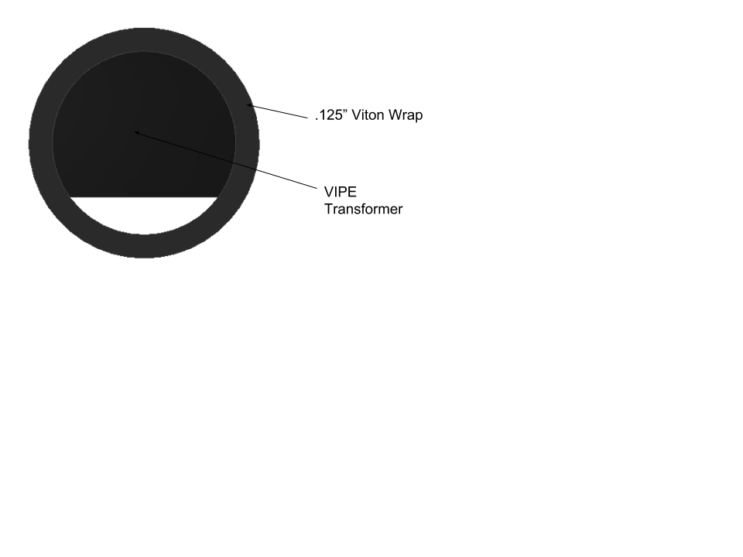

**Step 7**

* Fastening the transformer to the G10 shielding.
* Center the transformer on the G10 shielding and using 4- 91828A211 M3 hex nuts and two clamps fasten the transformer to the shielding.

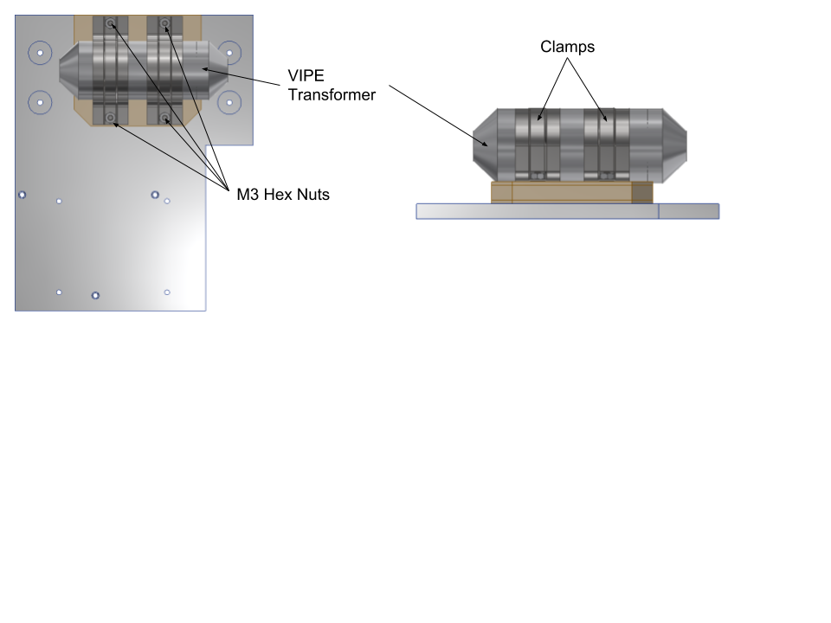

Fig7

# Part V

# Spark Gap Assembly

**Step 1**

* Assemble the G10 Shielding
* Insert 4-92010A787 M3 14mm Screws into the Spark Gap Insulation Middle Part
* Insert 4-92010A122 M3 12mm Screws into the Spark Gap Insulation Middle Part
* 12mm screws face up and will be used to fasten 2 clamps. The 14mm screws will be used to connect this piece to the baseplate
* Outer screws are 12mm Inner screws are 14mm
* These screws must be flush with the surface of the insulating plate, otherwise the assembly could become deformed.

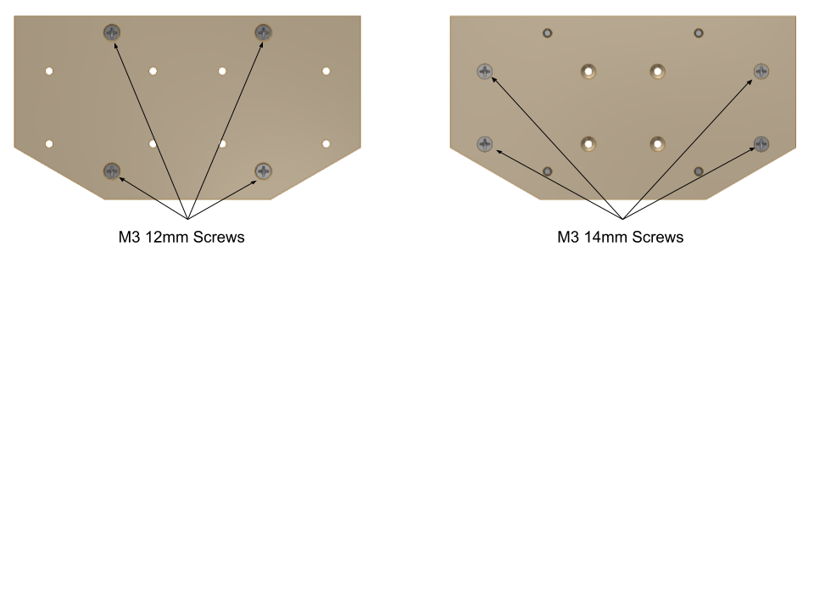

Fig8

**Step 2**

* Install the Spark Gap Insulation Bottom
* Insert the Spark Gap Insulation Bottom over the 8 screws that are on the bottom of the Spark Gap Insulation Middle.

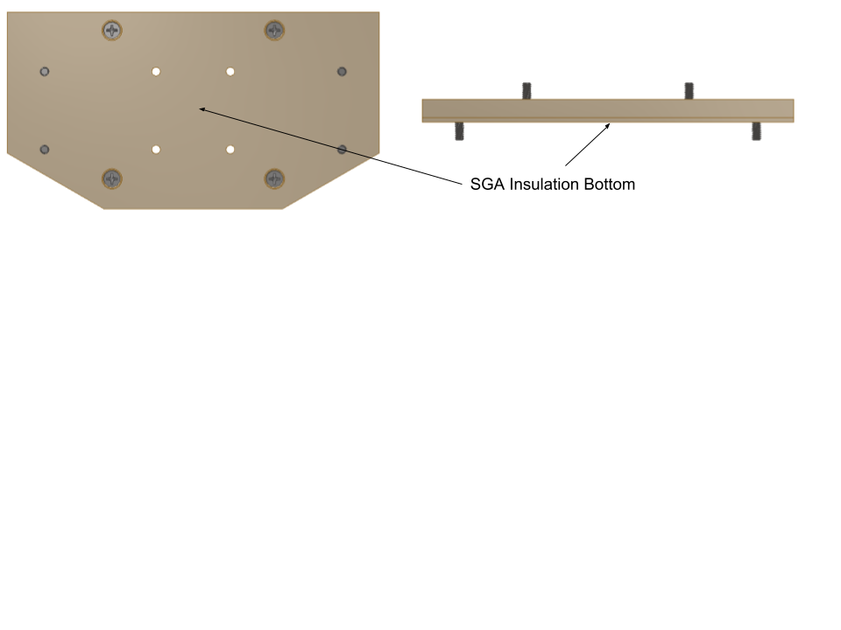

Fig9

* The Spark Gap Shielding Bottom should fit over the screws easily. If this piece forces any of the screws to not be perpendicular to the plate, then the rest of the installation will be difficult.

**Step 3**

* Install the Shielding plates to your mounting surface.
* The baseplate we used for flight had tapped holes and our lab test model had recesses for nuts. Either method is will work for assembly.
* Attach the 4 screws that pass through the shielding material to your baseplate using one of the two methods explained above. There should be no part of the screw that extends out from the baseplate on the opposite side. The nuts used will be 91828A211 M3 SS Hex Nuts

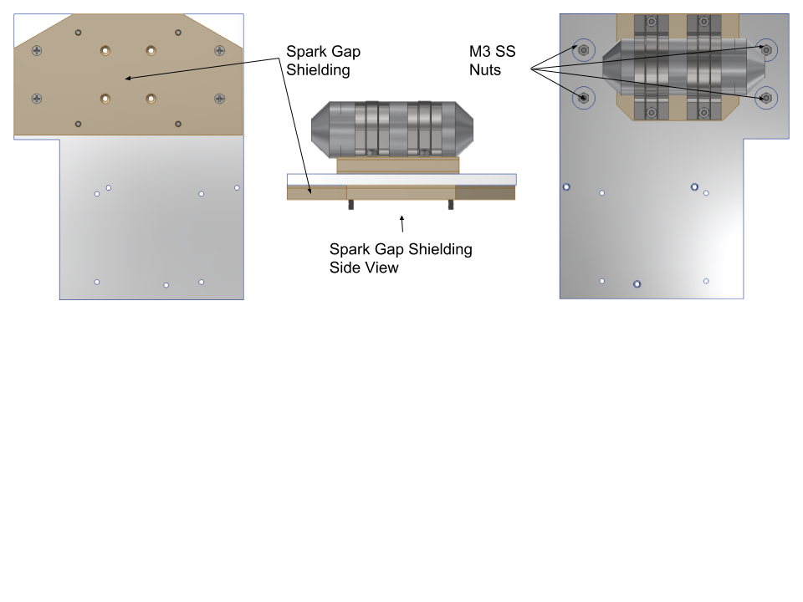

Fig10

**Step 4**

* Install the Spark Gap Shielding Top.
* Place the Spark Gap Shielding Top over the four screws and set this assembly aside in a safe area.

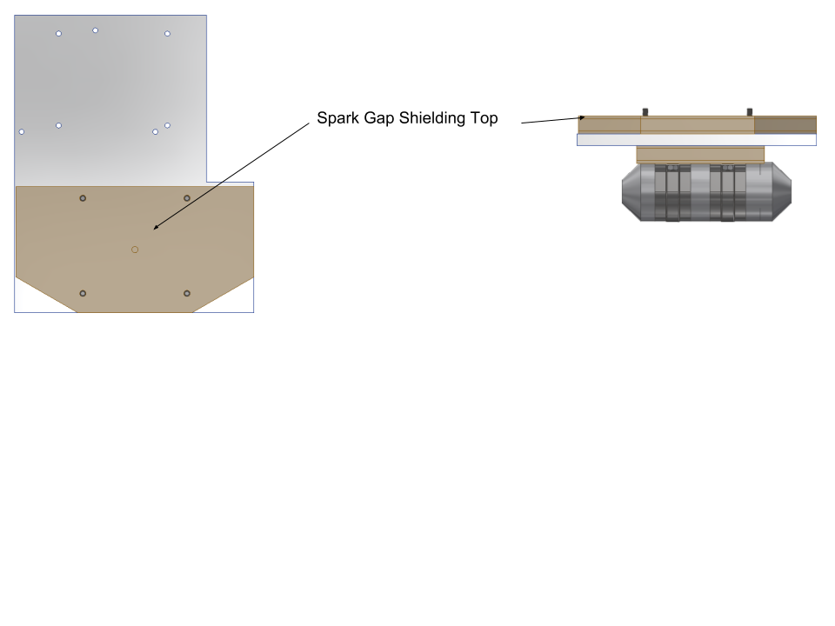

Fig11

* Ensure that the insulation layers do not hit any of the screws and push them to an odd angle.
* The clamps used to secure the Spark Gap are fastened using the four screws sticking out of the top of the G10 shielding plates and need to be in the correct position to make the clamp installation easy.
* The Spark Gap needs to be built at this point
* Place the assembly somewhere safe

**Step 5**

* Building the electrode assembly
* Gather the 2 electrodes, 2 inner baffles and 2 outer baffles.
* Build both electrode assemblies at the same time
* Insert the electrode into the small inner baffle. The large ring section (Largest diameter section) of the electrode should be towards the front of the inner baffle as shown in the picture.
* The threaded hole for the set screw should be unobstructed. If the baffle obstructs part of the hole use a small file to remove that part of the baffle
* It is important to not remove too much material from the baffle if you do this as it will cause a loose fit between the two parts. So only remove what is necessary

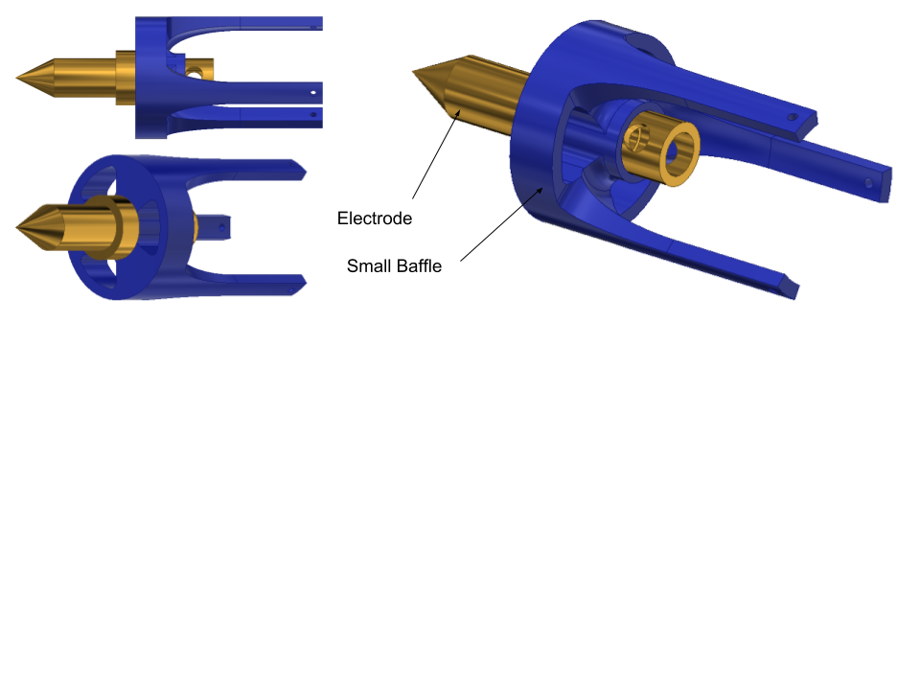

Fig12

**Step 6**

* Now connect the two wires that will go to the transformer to the two electrode assemblies by inserting them through into the back recess of the electrode. The wires should be around 6”. The wire should be ran through the set screw hole of the electrode and through the center of the set screw and out of the head of the screw
* Install set screw with wire inside

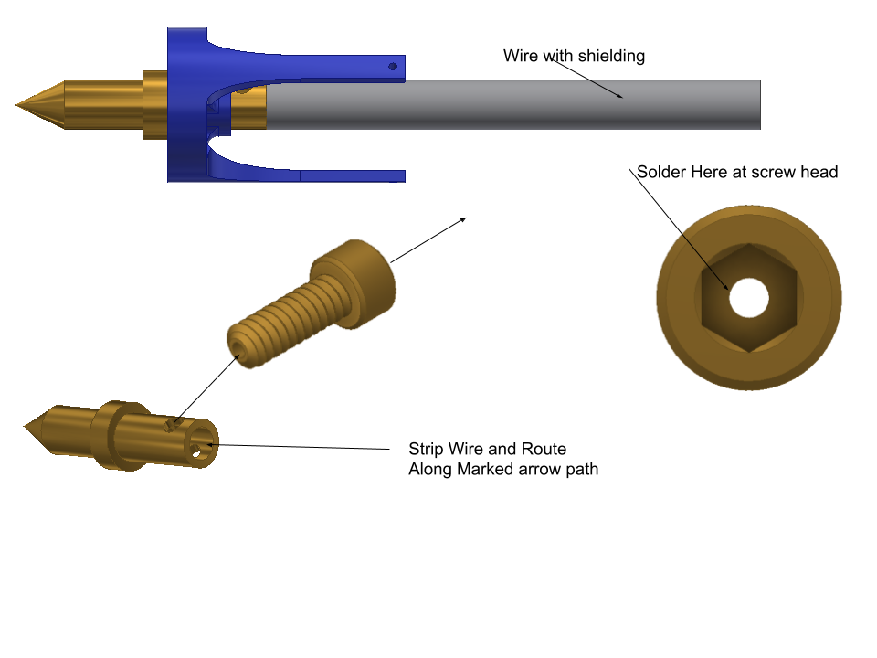

Fig13

**Step 7**

* Connecting the baffles
* Insert the outer inner baffle and electrode into the outer baffle. The three prongs of the inner baffle line up with holes in the outer baffle. The holes in the pongs of the inner baffle should be visible on the opposite face of the outer baffle.
* Run thin wire through the three small holes in the inner baffle to hold the assembly together. It is sufficient to do two complete wrappings of the small gauge wire to hold the baffles in place
* Solder the wire to the set screw at the screw head. Cut off any excess wire when done soldering.
* The electrode and baffle assembly is now complete.

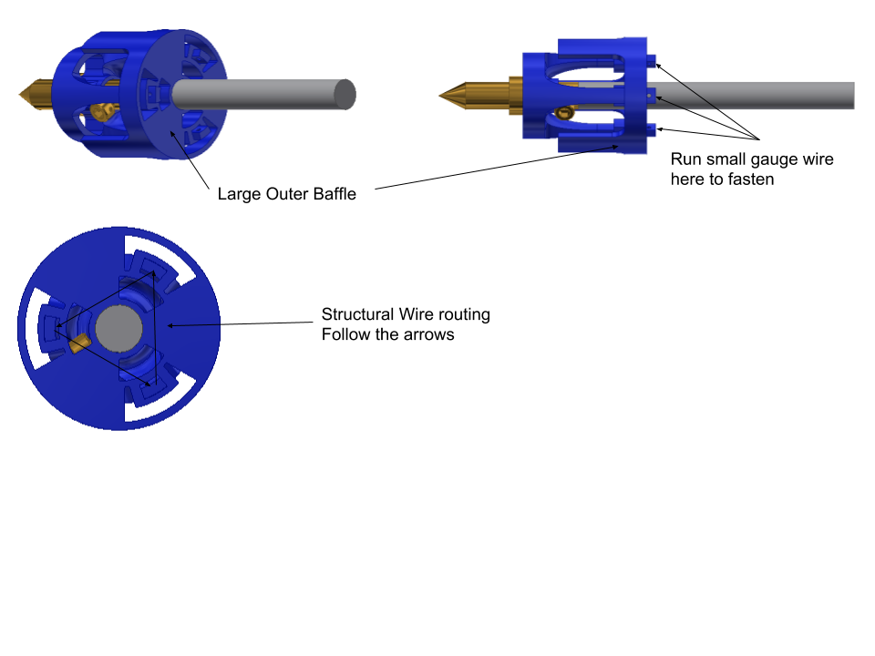

**Step 8**

* Wrap Quartz Tube in aluminum foil and .0625” Viton.
* Take a small piece of aluminum foil make sure it is flat and completely wrap the quartz tube leaving the ends open.
* Once the foil wrap is on the tube, wrap the Viton around the tube. The Viton should have the view window precut. You can use electrical tape to hold the Viton together around the tube. Now remove the foil from the viewing window using a tool that will not scratch the quartz tube. (I used my finger)

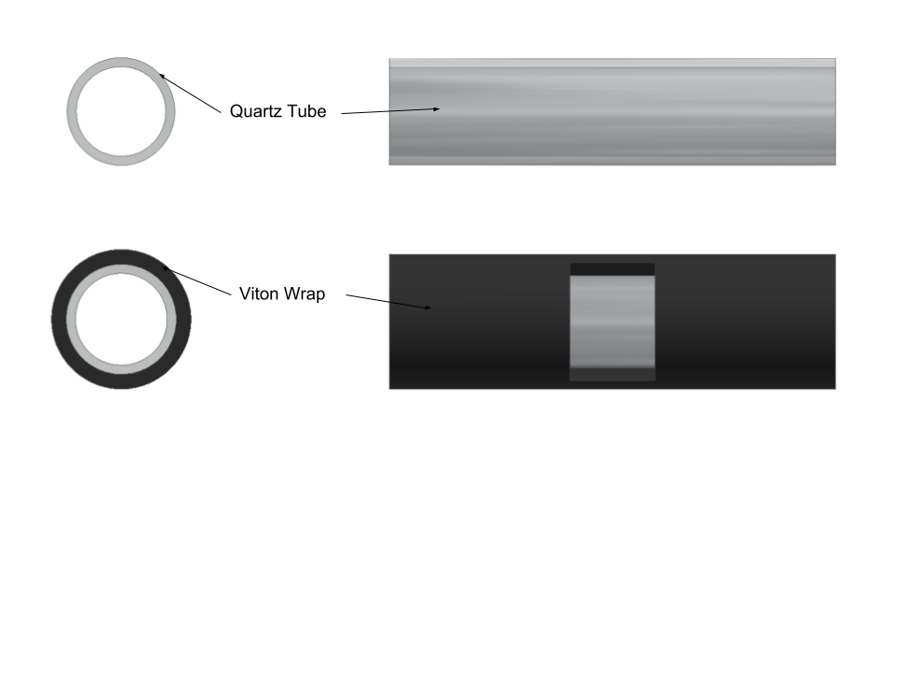

**Step 9**

* Install the electrode assemblies into the quartz tube.
* Insert the electrode assembly into the quart tube until the inner baffle is flush with the end of the quartz tube.
* The outer baffle prongs should go on the outside of the quartz tube and on the inside of the Viton.
* Be careful not to damage the foil wrap inside the Viton. This is difficult to accomplish but if it is damaged it is not critical to operation
* The electrodes should be visible in the viewing window

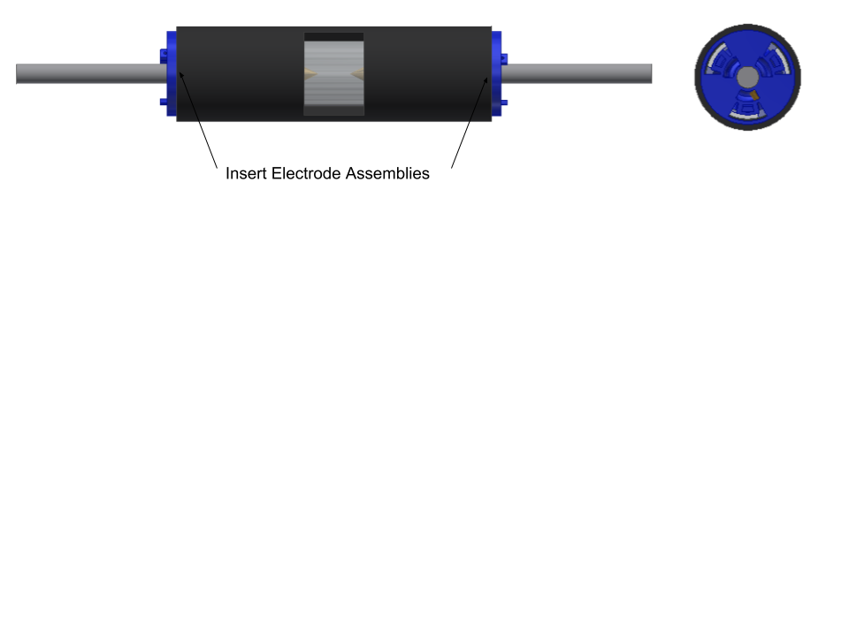

**Step 10**

* Wrapping the Spark Gap in Mesh Shielding
* Cut a 6”-7” length of the wire mesh shielding.
* Insert the Spark Gap Assembly into the mesh shielding making sure about 1.5” hangs over each end of the Spark Gap.

**Step 11**

* Mounting the Spark Gap to the G10 shielding
* Place the Spark Gap you just assembled and place it on the G10 Shielding assembly completed in Step 4.
* Make sure the viewing window is facing the direction of the rest of the payload and parallel to the baseplate and pointing towards the spectroscopy device.
* Place 2 clamps over the Spark Gap. They should fit over the four screws sticking out of the shielding.
* Using 4 91828A211 M3 hex nuts, install the clamps. The clamps should have a very snug fit and the Spark Gap should not move when the nuts are fully tightened.
* The images below do not show the wires attached in prior steps just the orientation of the Spark Gap on the base plate.

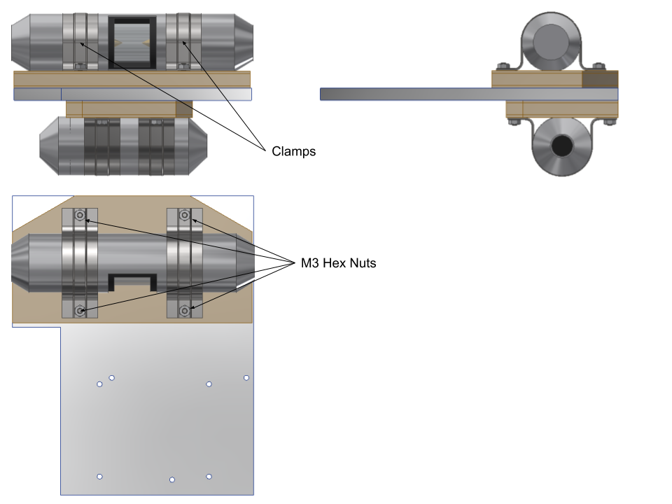

**Step 12**

* Wiring the transformer and the spark gap together.
* Install ferrite chokes on both sides of the transformer.
* Before connecting the wires between the transformer and the spark gap cut a length of the wire mesh shielding long enough to cover the wires between the two devices and slide it over the end of the wires of the transformer.
* Solder together the two leads from the spark gap to the two leads of the transformer making sure the transformer steps up the voltage to the spark gap.
* Extend the wire mesh shielding to cove the wiring.

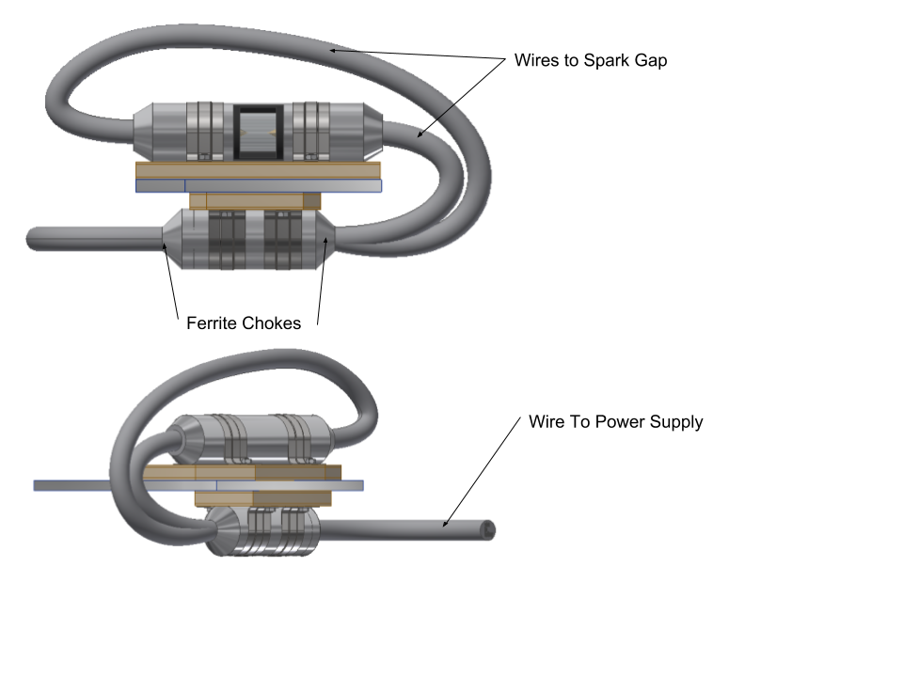

# Part VI

# Final Assembly

**Step 1**

* Using four .25” Delrin standoffs, four 92000A111 M2.5 20mm SS screws, four 92141A004 washers and four 91828A113 M2.5 hex nuts install the Raspberry Pi on the base plate on the same side as the transformer.

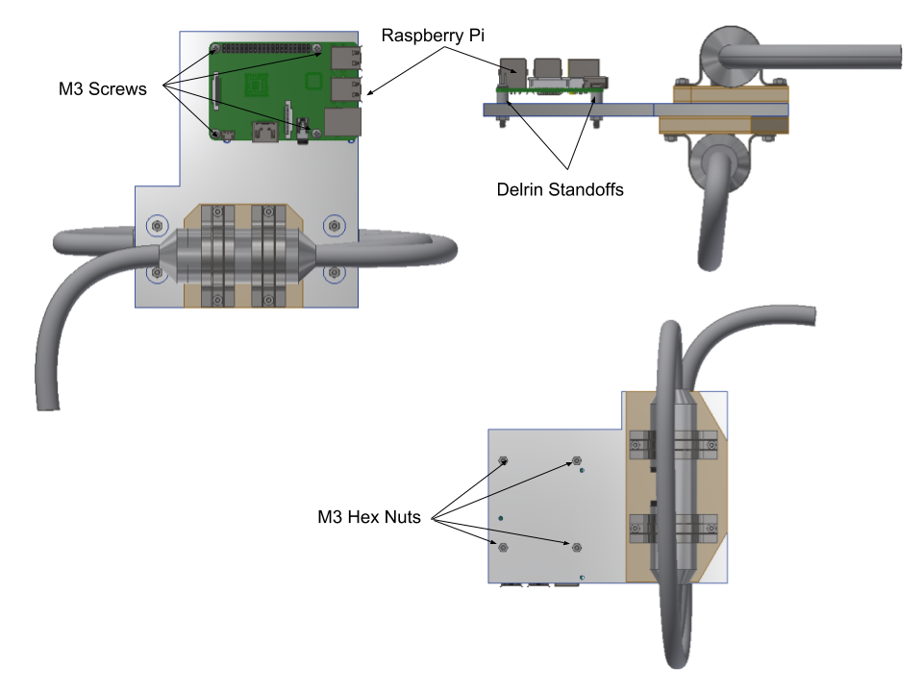

**Step 2**

* Install the Ocean Optic Spectroscopy Instrument
* Using the remaining 3 Delrin standoffs, three 91771A085 2-56 7/8” SS screws install the Ocean Optic Spectroscopy Instrument on the same side as the Spark Gap.
* The viewing window of the Spark Gap should line up with the camera of the Ocean Optic Spectroscopy Instrument.

*Note: It is very important that the two components line up properly to get accurate readings.*

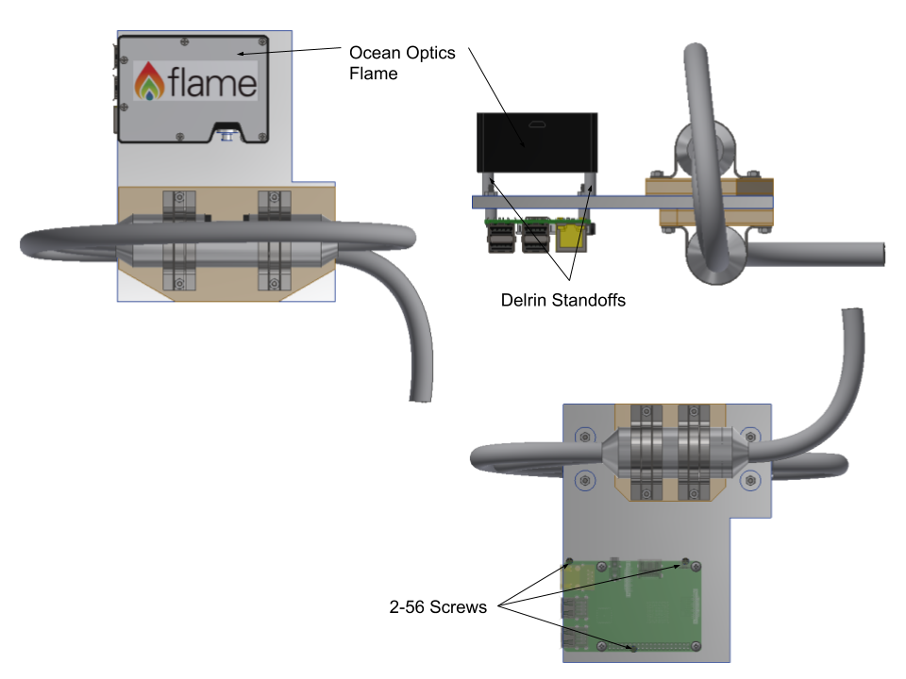

**Step 3**

* Connect your cables to the Raspberry Pi, Ocean Optics Flame and the Transformer

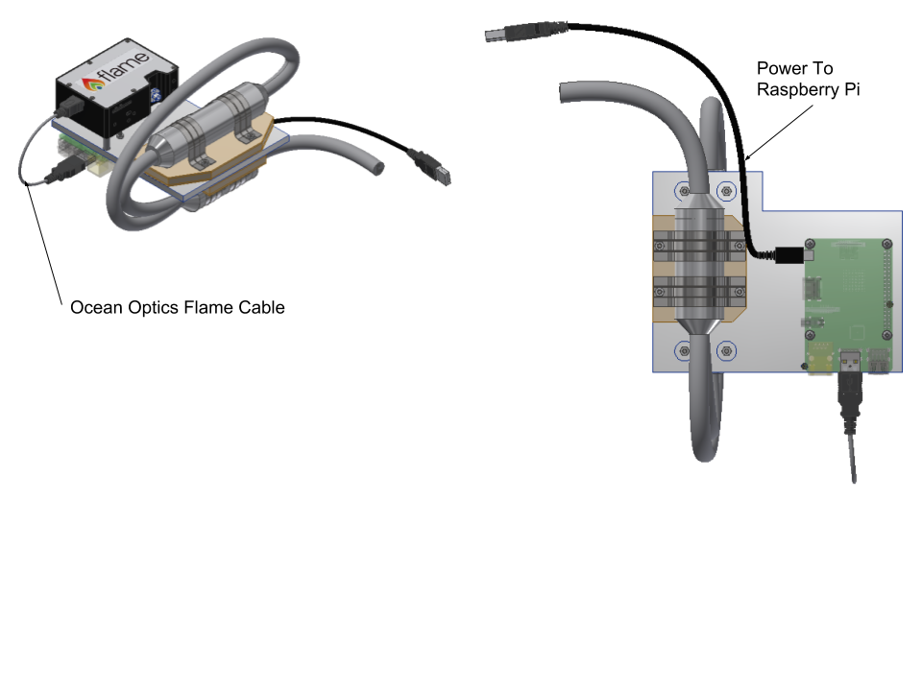

# Part VII

# Shop Drawings

# Part VIII

# Setting Up the Raspberry Pi

This section will explain how to set up a Raspberry Pi to operate the Ocean Optics Flame Spectrometer (Note: at the time of writing the software setup described below is NOT compatible with the Ocean Optics USB2000. To interface with an Ocean Optics USB2000 spectrometer use a standard windows computer with the OceanView software). It assumes one already has a Raspberry Pi 3 or Raspberry Pi 3+ running Raspbian Stretch (both the Lite and Desktop variants are acceptable). A basic familiarity with Linux as well as an understanding of basic Linux console commands (specifically: $mv, $cp, $rm, $mkdir, & $unzip) is necessary here. All referenced files are included in the same Github repository as this document (UMBC_DPLX_SPARK_2018).

1. Place the file “seabreeze-3.0.11.zip” in the directory /home/pi/Documents
2. Unzip the file
3. Run the command $sudo apt-get install libusb-dev
4. Locate the file “10-oceanoptics.rules” inside of /home/pi/Documents/seabreeze-3.0.11/SeaBreeze/os-support/linux and copy it to the directory /lib/udev/rules.d
5. Locate the file “Log.cpp” in /home/pi/Documents/seabreeze-3.0.11/SeaBreeze/src/common and delete this file
6. Place the “Log.cpp” file included with this document in the same folder where the faulty “Log.cpp” was just deleted
7. Place the files “demo-getSpectrumLoop.c” and “demo-integrationCalibration.c” in the directory /home/pi/Documents/seabreeze-3.0.11/SeaBreeze/sample-code/c
8. Inside of /home/pi/Documents create two new directories called “Data_Files” and “codeTesting”
9. Place the files “sparkGapOff.py”, “sparkGapOn.py”, and “intCalibrationManager.py” in the directory /home/pi/Documents/codeTesting
10. While inside of the /home/pi/Documents/codeTesting directory, run the command $sudo chmod +x sparkGapOff.py and $sudo chmod +x sparkGapOn.py
11. Move to the directory /home/pi/Documents/seabreeze-3.0.11/SeaBreeze and run the command $make (note: this step can take anywhere from 10 to 30 minutes)
12. Within the directory /home/pi/Documents/seabreeze-3.0.11/SeaBreeze/lib locate the file “libseabreeze.so” and copy it to the directory /lib/arm-linux-gnueabihf

**The Raspberry Pi Software**

Assuming the above instructions have been followed, two separate programs have been set up on the Raspberry Pi. The first is demo-getSpectrumLoop. When run, this program will infinitely request new back to back spectrums from the spectrometer, storing these spectrums in text files within the /home/pi/Documents/Data_Files directory. Each text file will be titled “SpecData_[number].txt”. For every other spectrum, the program will also toggle one of the ’s GPIO pins high to serve as a potential trigger to activate the spark gap or other light source should one desire. The default integration time is 3.5 seconds and the default trigger GPIO pin is 26, however both of these values can be changed by altering the program settings that can be found in the header of the file demo-getSpectrumLoop.c (note that after each edit, $make will need to be run in the directory /home/pi/Documents/seabreeze-3.0.11/SeaBreeze/sample-code/c). To run the program, simply use the command $./demo-getSpectrumLoop while in the /home/pi/Documents/seabreeze-3.0.11/SeaBreeze/sample-code/c directory.

The second program is demo-integrationCalibration. This program can be used to determine what the optimal integration time is for a given light source. When run, the program will run through a series of integration times from 5 seconds to .025 seconds, generating 10 spectrums for each time. The program will then repeat the process a second time to gather noise. This will generate 560 text files in the directory /home/pi/Documents/Data_Files. These text files can then be copied off of the pi to a windows machine (see the CalibrationFormatter section for more on using these files). To properly use this program, the spectrometer should be exposed to the light source in a steady manner, before beginning the program. The program should then be started and allowed to run for 17 minutes. After 17 minutes the light source should be turned off and the pi should be allowed to run for another ~17 minutes (or until the program completes). Once this is done, the files can be extracted. To run this program, simply use the command $python intCalibrationManager.py while in the directory /home/pi/Documents/codeTesting. It is worth noting that in addition to the 560 data files, every time this program is run it will also create a text file titled DataExists.txt. This file holds no data but rather serves to prevent accidentally overwriting the data. While this file exists, a new test cannot be run. To run a new test, simply delete this file.

NOTE: If at any time a command run on one or both of these programs fails, try appending “sudo” to the front of the command and running it again. For reasons not entirely clear, this is necessary on some Raspberry Pi’s but not others, even when they were supposedly set up identically.

**CalibrationFormatter**

Included with this document is a program called CalibrationFormatter. This program can be placed in a folder with the 560 text files generated by demo-integrationCalibration and run to format the files (note that this must be done on a windows machine). Upon running CalibrationFormatter it will read each file and average both the lit and background readings of each integration time. The background average will then be subtracted from the lit average of each (to subtract out noise) and the resulting spectrums will all be saved to a single text file titled ExcelFormat. This file can then be imported into excel using “:” as a delimiter to generate columns showing the spectrometer’s output at each of the tested integration times. These can then be compared to determine the optimal integration time for the given light source.

**Making Programs Run on Boot**

In several cases (especially when the pi is inside of a vacuum chamber and cannot be readily accessed) it may be beneficial to make a program run automatically as soon as the pi boots up. During the testing procedures laid out in section 10 the demo-integrationCalibration program was set to run automatically on boot so that once the appropriate pressure was reached, the pi could be powered and the test would begin automatically. This section will lay out how any program can be made to run automatically. It is worth noting that where program timing is involved, one should allow between 1 and 2 minutes for the pi to boot before the program will begin (this can vary based on what else is installed on the pi).

To begin, enter the command $sudo nano /etc/rc.local. This will open an editor where a text file can be edited. Used the arrow keys to move down to the final line of the file before “exit 0”. On a new line before the “exit 0”, enter the same command described above to start the desired program. However, replace the name of the program with the complete file path to the program’s location. Following this, enter a space and a “&”. As an example, to make demo-integrationCalibration run on startup this line should read “sudo python /home/pi/Documents/codeTesting/intCalibrationManager.py &”. Once this is complete, the specified program will automatically run the next time the pi boots.

# Part IX

# Manufacturing

|  |  |  |  |
| --- | --- | --- | --- |
| **Parts** | **Tools Used** | **Method** | **Notes** |
| Electrode Holders | SLA Printer  Sandpaper  Swiss Files | Precise sanding/filing may be required to remove excess print resin and ensure good fit inside of quartz tube | Manufactured at UMBC  Due to quartz tube tolerance, baffles may need sanding for good fit |
| Standoffs (for Pi) | Saw  Drill Press | Use saw to cut Delrin to length  Use drill press to cut hole for the screw  Can also be turned on lathe | Delrin Piece ordered from McMaster  Screw diameter = 0.086" |
| Base Plate | Milling Machine | Manual milling or CNC milling required | CNC Milling recommended due to part complexity and tolerance requirements |
| G10 | Laser Cutter | Machine it or laser cut, depending on thickness | Used 3 smaller laser cut sheets made by hand |
| Viton for transformer | X-ACTO knife | Cut with X-ACTO knife | Trim excess once installed |
| Electrodes for Spark Gap | Machined | Turned from round stock on lathe | Manufactured at UMBC |
| Wire Mesh | Tin snips | Compress to size of transformer to increase the diameter and decrease the length.  (Do this before cutting for better fit) | Wear Gloves (Safety Concern for metal splinters) |
| Clamps | Vice  Drill Press  Hacksaw | There are ridges on both ends of clamps. Take the vice and tighten to make it flat. Once flat, position it on the pre-cut G10 and mark where the holes should be located on the G10. Use drill to cut 5/32-inch holes. | Take a hacksaw and cut of the excess |

# Part X

# Testing

**Testing Conducted with the Flight Spectrometer during July of 2018**

Once the test rig was assembled, testing was conducted in vacuum chambers both at UMBC and UMD. Each test was conducted in the 5E-5 Torr region. Each test was conducted as follows: The Raspberry Pi was set up so that the demo-integrationCalibration program would run automatically on boot. The entire test rig was then inserted into the vacuum chamber. Exterior wires were run to the leads of the spark gap while an exterior micro-USB line was run to the Raspberry Pi’s power port. Both lines were unpowered during this test. The vacuum chamber was then sealed and pumped down. Once the chamber ultimate pressure reached ~5E-5 torr, 7.4V was provided to the spark gap, and the Raspberry Pi was powered with 5V and 2.5A. From the moment the Raspberry Pi was powered a stopwatch was manually triggered. When 19 minutes had passed (17 minutes for the test + 2 minutes to allow for boot) the spark gap was depowered. After another 17 minutes the Raspberry Pi was also depowered. With this done the test was complete and the chamber was repressurized. The test rig was then removed, and the data files were pulled from the pi via SSH.

The above procedure was used during the first two tests with the test rig. Future tests followed the same procedure with one variation. It was determined that constant power could potentially damage the transformer, thus future tests manually pulsed the power to the spark gap, with 6 seconds on and 6 seconds off. Unfortunately, this method renders the CalibrationFormatter program useless and the data must be formatted manually.

References

Fig6

Transformer

<https://www.aliexpress.com/item/DC-3-6V-6V-To-400KV-Boost-Step-Up-Power-Module-High-Voltage-Generator-For-Rc/32655019918.html>

Fig6

Wiring

https://www.digikey.com/catalog/en/partgroup/hi-flex-unshielded/30524